**Question Bank**

**Q1. Goals of Forensic report(2M)**

**Documentation of Evidence**: A forensic report aims to document all relevant evidence collected during the investigation. This includes physical evidence, digital artifacts, witness statements, and any other pertinent information.

**Analysis and Interpretation**: The report should provide an analysis of the evidence collected, including any examinations, tests, or analyses conducted. It should interpret the findings in the context of the case and relevant forensic methodologies.

**Clarity and Precision**: Forensic reports need to be clear, concise, and written in a language that is easily understood by non-technical stakeholders such as lawyers, judges, or jurors. Precision in language and terminology is crucial to avoid ambiguity.

**Objectivity and Impartiality**: It is essential for forensic reports to maintain objectivity and impartiality. They should present findings without bias or prejudice, allowing the reader to form their own conclusions based on the evidence presented.

**Compliance and Standards**: Depending on the jurisdiction and the nature of the investigation, forensic reports may need to adhere to specific legal standards, regulations, or professional guidelines. Compliance with these standards ensures the admissibility and reliability of the report in legal proceedings.

**Support for Legal Proceedings**: Forensic reports often serve as crucial pieces of evidence in legal proceedings, providing support for prosecutors, defense attorneys, or other parties involved in the case. The report should be structured and formatted in a way that facilitates its use in court.

**Transparency and Accountability**: Transparency in the methodology used and the rationale behind conclusions is vital for maintaining the credibility of the forensic report. It should clearly outline the steps taken during the investigation and justify the conclusions reached.

**Risk Mitigation**: In cases where the forensic analysis involves potential risks or uncertainties, the report should communicate these effectively. It is important to identify limitations, assumptions, and uncertainties associated with the findings to avoid misinterpretation or misunderstanding.

**Q2. Types of Digital Forensics.Explain Process with neat diagram**

**The types of digital forensics are:**

**Disk Forensics:**

It deals with extracting data from storage media by searching active, modified, or deleted files.

**Network Forensics:**

It is a sub-branch of digital forensics. It is related to monitoring and analysis of computer network traffic to collect important information and legal evidence.

**Wireless Forensics:**

It is a division of network forensics. The main aim of wireless forensics is to offers the tools need to collect and analyze the data from wireless network traffic.

**Database Forensics:**

It is a branch of digital forensics relating to the study and examination of databases and their related metadata.

**Malware Forensics:**

This branch deals with the identification of malicious code, to study their payload, viruses, worms, etc.

**Email Forensics**

Deals with recovery and analysis of emails, including deleted emails, calendars, and contacts.

**Memory Forensics:**

It deals with collecting data from system memory (system registers, cache, RAM) in raw form and then carving the data from Raw dump.

**Process:**

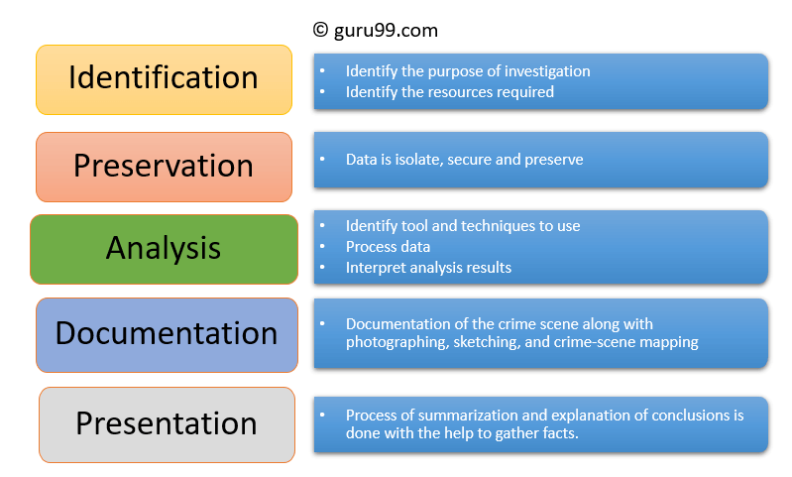

**Identification**

It is the first step in the forensic process. The identification process mainly includes things like what evidence is present, where it is stored, and lastly, how it is stored (in which format).

Electronic storage media can be personal computers, Mobile phones, PDAs, etc.

**Preservation**

In this phase, data is isolated, secured, and preserved. It includes preventing people from using the digital device so that digital evidence is not tampered with.

**Analysis**

In this step, investigation agents reconstruct fragments of data and draw conclusions based on evidence found. However, it might take numerous iterations of examination to support a specific crime theory.

**Documentation**

In this process, a record of all the visible data must be created. It helps in recreating the crime scene and reviewing it. It Involves proper documentation of the crime scene along with photographing, sketching, and crime-scene mapping.

**Presentation**

In this last step, the process of summarization and explanation of conclusions is done.

However, it should be written in a layperson’s terms using abstracted terminologies. All abstracted terminologies should reference the specific details.

**Q3. Types of Cyber Crime**

**Cyber crimes can be classified in to 4 major categories as the following:**

**1) Cyber crime against Individual**

**(2) Cyber crime Against Property**

**(3) Cyber crime Against Organization**

**(4) Cyber crime Against Society**

**(1) Against Individuals:**

**(i) Email spoofing :** A spoofed email is one in which the e-mail header is forged so that the mail appears to originate from one source but actually has been sent from another source.

**(ii) Spamming :** Spamming means sending multiple copies of unsolicited mails or mass e-mails such as chain letters.

**(iii) Harassment & Cyber stalking :** Cyber Stalking Means following an individual's activity over internet. It can be done with the help of many protocols available such as e- mail, chat rooms, user net groups.

**(2) Against Property**

**(i) Credit Card Fraud :** As the name suggests, this is a fraud that happens by the use of a credit card. This generally happens if someone gets to know the card number or the card gets stolen.

**(ii) Intellectual Property crimes :** These include Software piracy: Illegal copying of programs, distribution of copies of software. Copyright infringement: Using copyrighted material without proper permission. Trademarks violations: Using trademarks and associated rights without permission of the actual holder. Theft of computer source code: Stealing, destroying or misusing the source code of a computer.

**(iii) Internet time theft :** This happens by the usage of the Internet hours by an unauthorized person which is actually paid by another person.

**(3) Against Organisations**

**(i) Unauthorized Accessing of Computer:** Accessing the computer/network without permission from the owner. It can be of 2 forms:

**a) Changing/deleting data:** Unauthorized changing of data.

**b) Computer voyeur:** The criminal reads or copies confidential or proprietary information, but the data is neither deleted nor changed.

**(ii) Denial Of Service :** When Internet server is flooded with continuous bogus requests so as to denying legitimate users to use the server or to crash the server.

**(iii) Computer contamination / Virus attack :** A computer virus is a computer program that can infect other computer programs by modifying them in such a way as to include a (possibly evolved) copy of it. Viruses can be file infecting or affecting boot sector of the computer. Worms, unlike viruses do not need the host to attach themselves to.

**(iv) Email Bombing :** Sending large numbers of mails to the individual or company or mail servers thereby ultimately resulting into crashing.

**(v) Salami Attack :** When negligible amounts are removed & accumulated in to something larger. These attacks are used for the commission of financial crimes.

**(vi) Logic Bomb :** It is an event dependent program. As soon as the designated event occurs, it crashes the computer, release a virus or any other harmful possibilities.

**(vii) Trojan Horse :** This is an unauthorized program which functions from inside what seems to be an authorized program, thereby concealing what it is actually doing.

**(viii) Data diddling :**

Data diddling is a form of computer-based fraud where an individual manipulates or alters data with the intent of deceiving others or gaining some form of unauthorized advantage. This type of manipulation is often done discreetly, and the alterations might be subtle to avoid detection. The term "data diddling" is derived from the act of tweaking or diddling with data.

**(4) Against Society**

**(i) Forgery :** Currency notes, revenue stamps, mark sheets etc. can be forged using computers and high quality scanners and printers.

**(ii) Cyber Terrorism :** Use of computer resources to intimidate or coerce people and carry out the activities of terrorism.

**(iii) Web Jacking :** Hackers gain access and control over the website of another, even they change the content of website for fulfilling political objective or for money.

**Cyberbullying**: Bullying an individual online is referred to as cyberbullying. Cyberbullying includes any threat to a person’s safety, coercion of a person to say or do anything, and expressions of hatred or subjectivity against someone. While children are more likely to be victims of cyberbullying, adults are not exempt. According to a survey, 40% of polled teens said they had encountered online harassment, while 24% of adults aged 26–35 said they had experienced cyberbullying.

**Malware**: Malware is a term that refers to any software program that is meant to infiltrate or harm a device. Viruses are a type of software that falls under the malware category. Viruses may cause a range of problems once they enter a device. They may delete files, record your keystrokes, erase your disk drive, or otherwise corrupt your data.

**Phishing**: Phishing happens when fraudsters act as an organisation in order to dupe victims into disclosing important information. Scare techniques, such as notifying the victim that their bank account or personal device is under assault, are frequently used by cybercriminals to effectively fulfil their phishing aims.

**Q4. Layout of an Forensic report(list out)**

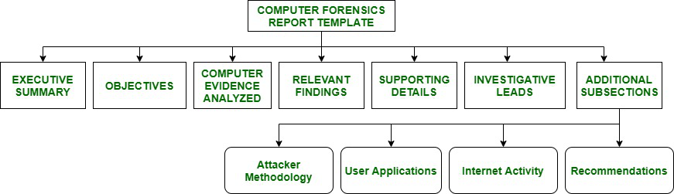

**Executive Summary:**

Executive Summary section of the computer forensics report template provides background data of conditions that need a requirement for investigation. The executive Summary or the Translation Summary is read by Senior Management as they do not read the detailed reports. This section must contain a short description, details, and important pointers.

**Objectives:**

The objectives section is used to outline all tasks that an investigation has planned to complete. In some cases, it might happen that forensics examination may not do a full-fledged investigation when reviewing the contents of media. The prepared plan list must be discussed and approved by the legal counsel, decision makers, and client before any forensic analysis. This list should consist of tasks undertaken and methods undertaken by an examiner for each task and the status of each task at the end of the report.

**Computer Evidence Analyzed:**

The Computer Evidence Analyzed section is where all gathered evidence and its interpretations are introduced. It provides detailed information regarding the assignment of evidence’s tag numbers, description of evidence, and media serial numbers.

**Relevant Findings:**

This section of Relevant Findings gives a summary of evidence found of probative Value When a match is found between forensic science material recovered from a crime scene e.g., a fingerprint, a strand of hair, a shoe print, etc., and a reference sample provided by a suspect of the case, the match is widely considered as strong evidence that suspect is the source of recovered material. However, the probative value of evidence can vary widely depending on way in which evidence is characterized and the hypothesis of its interest. It answers questions such as “What related objects or items were found during the investigation of case ?”.

**Supporting Details :**

Supporting Details is section where in-depth analysis of relevant findings is done. ‘How we found conclusions outlined in Relevant Findings?’, is outlined by this section. It contains table of vital files with a full path name, results of string searches, Emails/URLs reviewed, number of files reviewed and any other relevant data. All tasks undertaken to meet objectives is outlined by this section. In Supporting Details we focus more on technical depth. It includes charts, tables and illustrations as it conveys much more than written texts. To meet outlined objectives, many subsections are also included. This section is longest section. It starts with giving background details of media analyzed. It is not easy to report number of files reviewed and size of hard drive in a human understandable language. Therefore, your client must know how much data you wanted to review to arrive at a conclusion.

**Investigative Leads:**

Investigative Leads perform action items that could help to discover additional information related to the investigation of the case. The investigators perform all outstanding tasks to find extra information if more time is left. The investigative Lead section is very critical to law enforcement. This section suggests extra tasks that discover information needed to move on the case. e.g. finding out if there are any firewall logs that date far enough into the past to give a correct picture of any attacks that might have taken place. This section is important for a hired forensic consultant.

**Additional Subsections:**

Various additional subsections are included in a forensic report. These subsections are dependent on clients' wants and their need. The following subsections are useful in **specific cases:**

**Attacker Methodology –**

Additional briefing to help reader understand general or exact attacks performed is given in this section of attacker methodology. This section is useful in computer intrusion cases. Inspection of how attacks are done and what bits and pieces of attacks look like in standard logs is done here.

**Internet Activity –**

Internet Activity or Web Browsing History section gives web surfing history of user of media analyzed. The browsing history is also useful to suggest intent, downloading of malicious tools, unallocated space, online researches, downloading of secure deleted programs or evidence removal type programs that wipe files slack and temporary files that often harbor evidence very important to an investigation.

**Recommendations –**

This section gives recommendation to posture client to be more prepared and trained for next computer security incident. We investigate some host-based, network-based and procedural countermeasures are given to clients to reduce or eliminate risk of incident security.

**Forensic Report Format**

There really isn’t a de-facto standard or format per-se. Formatting and layout options are up to the examiner/analyst, or they may be defined by organizational policies or jurisdictional court rules. The report may include something similar or a slightly different flavor to the following:

Title Page

Table of Contents

Overview/Case/Executive Summary

Evidence

Objectives

Forensic Analysis (Steps Taken)

Relevant Findings

Conclusion

Exhibit

**Q5. Types of Cyber criminals**

**1. Hackers:** The term hacker may refer to anyone with technical skills, however, it typically refers to an individual who uses his or her skills to achieve unauthorized access to systems or networks so as to commit crimes. The intent of the burglary determines the classification of those attackers as white, grey, or black hats.

**(a). White Hat Hackers –** These hackers utilize their programming aptitudes for a good and lawful reason. These hackers may perform network penetration tests in an attempt to compromise networks to discover network vulnerabilities. Security vulnerabilities are then reported to developers to fix them.

**(b). Gray Hat Hackers –** These hackers carry out violations and do seemingly deceptive things however not for individual addition or to cause harm. These hackers may disclose a vulnerability to the affected organization after having compromised their network.

**(c). Black Hat Hackers –** These hackers are unethical criminals who violate network security for personal gain. They misuse vulnerabilities to bargain PC frameworks.

**2. Internet stalkers:** Internet stalkers are people who maliciously monitor the

web activity of their victims to acquire personal data. This type of cyber crime is conducted through the use of social networking platforms and malware, that are able to track an individual’s PC activity with little or no detection.

**3. Disgruntled Employees:** Disgruntled employees become hackers with a particular motive and also commit cyber crimes. It is hard to believe that dissatisfied employees can become such malicious hackers. In the previous time, they had the only option of going on strike against employers. But with the advancement of technology there is increased in work on computers and the automation of processes, it is simple for disgruntled employees to do more damage to their employers and organization by committing cyber crimes. The attacks by such employees brings the entire system down.

**4. Phreakers:** They are the ones who gain illegal access to the telephone system. They are considered to be the original computer hackers as they are the ones who break into telephone system illegally and make long distance calls. Phreaker word is a combination of, “Phone” + “Freak”. Many real hackers are phreakers since they deduct the cost of their telephone bills and continue skimming off networks in a more serene way. The emergence of the Internet and the significant fall in the costs of Telecommunications has remedied a great part to this problem. Nevertheless, there are phreakers who still take up the challenge to hack telephone networks.

**Q6. Anti Forensics**

Anti-forensics, also known as counter-forensics, refers to the techniques and methods employed to deliberately thwart or undermine digital forensic investigations. The goal of anti-forensics is to disrupt or manipulate the collection, analysis, and preservation of digital evidence, making it more challenging for forensic investigators to uncover information about cybercrimes or illicit activities. Individuals or entities engaging in anti-forensic practices often seek to cover their tracks, obscure evidence, or mislead investigators.

Common anti-forensic techniques include

**Data Deletion:**

Permanently erasing or overwriting data to make it unrecoverable. This can include using secure deletion tools to overwrite free space on storage media.

**Data Encryption:**

Encrypting sensitive data to prevent unauthorized access. If investigators do not have access to the decryption key, the information remains inaccessible.

**Steganography:**

Embedding data within other files or media in a way that is not immediately apparent. This technique aims to hide the existence of information rather than encrypt it.

**File System Manipulation:**

Altering file system metadata or timestamps to mislead investigators about the timeline of events or actions taken on a system.

**Network Anonymization:**

Using techniques such as virtual private networks (VPNs), proxy servers, or Tor to obfuscate the source of network traffic, making it difficult to trace back to the original user.

**Memory Scrubbing:**

Clearing or overwriting volatile memory (RAM) to eliminate traces of running processes or sensitive information stored in memory.

**File Deletion and Shredding:**

Deleting files and then securely shredding the storage space previously occupied by those files to make recovery more difficult.

**Attack on Forensic Tools:**

Targeting and disabling or evading forensic tools and software that investigators use to analyze systems.

**Tampering with Timestamps:**

Manipulating file timestamps to create false timelines or hide the actual sequence of events.

**Data Fragmentation:**

Splitting data into smaller fragments and storing them in different locations to complicate reconstruction and analysis.

**Booby Trapping:**

Placing false or misleading information within systems to misdirect investigators and waste their time.

It's important to note that engaging in anti-forensic activities is often illegal and can lead to serious legal consequences. Law enforcement and digital forensic professionals continually work to develop countermeasures and techniques to overcome challenges posed by anti-forensics. Despite these efforts, the cat-and-mouse game between forensic investigators and individuals using anti-forensic techniques continues to evolve in the cybersecurity landscape.

**Q7. Digital Forensics**

* Digital Forensics (also widely known as computer forensics) is the process of investigating crimes committed using any type of computing device (such as computers, servers, laptops, cell phones, tablets, digital camera, networking devices, Internet of Things (IoT) device or any type of data storage device).
* Digital forensics is also responsible for examining attacks originated from cyberspace like ransomware, phishing, SQL injection attacks, distributed denial-of-service (DDoS) attacks, data breach and any sort of cyberattacks that cause financial or reputation losses.
* The ultimate goal of a digital forensics investigation is to preserve, identify, acquire and document digital evidence to be used in the court of law.
* Under this definition, digital forensics is used to investigate any crime that involves using electronic devices, whether these devices were used to commit or as a target of a crime.
* Having a digital forensics capability becomes very important for modern organizations to investigate internal policy violations and external attacks against their computerized systems, for instance, big corporations already have such capability that exceeds the capability of many government police departments.

**Process of Digital Forensics:**

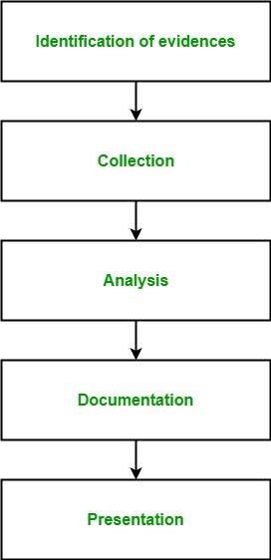

**Identification of evidence:** It includes of identifying evidences related to the digital crime in storage media, hardware, operating system, network and/or applications. It is the most important and basic step.

**Collection:** It includes preserving the digital evidences identified in the first step so that they doesn’t degrade to vanish with time. Preserving the digital evidences is very important and crucial.

**Analysis:** It includes analyzing the collected digital evidences of the committed computer crime in order to trace the criminal and possible path used to breach into the system.

**Documentation:** It includes the proper documentation of the whole digital investigation, digital evidences, loop holes of the attacked system etc. so that the case can be studied and analysed in future also and can be presented in the court in a proper format.

**Presentation:** It includes the presentation of all the digital evidences and documentation in the court in order to prove the digital crime committed and identify the criminal.

**Q8. What are preventive and protective mech against cyber attacks**

**Prevention**

**Use complex passwords:** Use various login details combinations for separate accounts and avoid writing them down.

**Keeping online profiles secret:** Make sure to keep your social networking profiles (Facebook, Twitter, YouTube, and so on) private. Make sure to double-check your security settings. Take caution with the information you put on the internet. Once it’s on the Internet, it’s there for good.

**Safeguarding data:** Encrypt sensitive files such as financial documents and tax returns, to protect your data.

**Safeguard mobile devices:** Many individuals are unaware that their mobile devices are exposed to dangerous software such as computer viruses. An individual should only download software from reputable sites. It is also critical that your operating system is kept up to date. Install anti-virus software and utilize a secure lock screen in addition. Otherwise, if you misplace your phone or lay it down for a few seconds, anyone may see all of your personal information on it. Someone may even install malicious software that uses GPS to follow your every step.

**Secure online identity:** When it comes to protecting one’s identity online, an individual should be vigilant. When providing personal information such as your name, address, phone number, and/or financial information on the Internet, you must exercise extreme caution. While making an online purchase, etc., be sure to check whether the websites are safe. This includes turning on your privacy settings while using or visiting social networking sites.

**Safeguarding computers with security software**: For basic internet security, several types of security softwares are required. Firewall and antivirus software are key pieces of security software. A firewall is typically the first line of defence for your computer. It governs who can communicate, and access the computer via the internet. Assume a firewall to be a type of ‘policeman’ who monitors all data attempting to flow to and from the computer via the Internet, permitting transactions that it knows are secure while preventing ‘bad’ traffic such as cyberattacks.

**Protection:**

In order to protect ourselves from the perils of cybercrime, the following preventative actions can be taken:

* It is required to install an antivirus program. An antivirus program is designed to safeguard users against cybercrime. Modern programs monitor the machine’s data for harmful content and give real-time security against dangers like phishing.
* Making use of a Virtual Private Network. A VPN connection will protect your online privacy. It’s an important tool for privacy, which protects people from identity theft.
* Unsolicited emails, text messages, and phone calls should be avoided, especially if they utilise the crisis to coerce people into circumventing standard security safeguards.
* Change the Wi-Fi network’s default password to something more secure. Limit the number of devices that may connect to the Wi-Fi network and only allow trustworthy devices to connect.
* Use lengthy and complicated passwords that incorporate numbers, letters, and special characters.
* Make sure to update all the systems and programs, as well as to install and maintain an antivirus software up to date.
* Data backup should be a routine procedure since data may be quickly destroyed, infected, or manipulated.

**Q9. What are digital evidences Explain its types**

* To bring the guilty to justice, correctly collecting, analyzing, and presenting the right evidence is quintessential. Before proceeding with the investigation, however, you’re going to need to know where and how to look for certain digital evidence. After all, collecting different types of digital evidence requires different tools and methodologies to be used in the process.
* When it comes to digital evidence, in essence, it can be anything from logs and all the way to video footage, images, archives, temporary files, replicant data, residual data, metadata, active data, and even data that’s stored inside a device’s RAM (otherwise known as volatile data), as long as they are regarded as part of clue for a digital investigation.

**Types:**

1. **Logs**
   1. **OS logs**

Examples include events pertaining to system access, security alerts, the duration of a user’s login session, when the device was shut down, etc.

Typically, OS logs are stored in a particular system directory (the exact location depends on the operating system in use).

* 1. **Database logs**

Since they mostly reveal what changes were made to a particular database, these can be a vital source of crime evidence as well as a useful approach for debugging and troubleshooting in the unfortunate event of any technical

issues with the database in question.

* 1. **Email logs**

Often presented in a CSV format, email logs can reveal certain details about the sender and content, which includes their email address, time and date of delivery, delivery status, cc, bcc, subject, content type, and error codes (if applicable), while mostly stored in the email’s header.

Many cyber criminals use email as their go-to communication channel

for the purposes of extortion, financial crime, and distributing illegal

materials.Alongside email logs, any file attachments also count as one of the evidence types, so they should be closely examined, right along with

the server logs through which the email was sent.

* 1. **Phone logs**

A phone’s infrastructure encompasses various kinds of evidence, including photos taken, videos recorded, system logs, app logs, and

call logs, the latter of which contain crucial details such as the

duration of a call, inbound and outbound numbers, etc.

* 1. **Network logs**

These can be viewed as different types of evidence because they

also contain clues about what an individual was doing on the

internet, including what websites that person has visited, what

messages were exchanged with another party, and what the content

of the messages was.

* 1. **IP logs**

Since everyone who browses the internet gets assigned a unique IP

address, knowing this crucial detail allows a digital forensics

investigator to trace their real identity and physical location by

cooperating with ISPs.

IP logs are often a crucial source of evidence when trying to hunt

down a cyber-criminal.

* 1. **Server logs**

These kinds of logs are like digital journal that records the events

taking place on a server. Examples include IP addresses that

connected to the server at any point in time and also the duration of

each session, any error logs, usernames that were used during the

time of access, etc.

* 1. **Device fingerprints**

There are many forensic categories of devices where evidence can

be found, and each device can generate a unique fingerprint that

consists of its hardware specs, the OS it’s running (down to the exact

version), and even other odd bits and pieces such as the graphics

drivers it’s running or what fonts are installed.

Therefore, even if a cybercriminal attempts to mask their IP when

connecting to a server, the device fingerprint can be collected

regardless.

1. **Video footage and images**
2. **Archives**

Since archives are regular files accessible straight from the file explorer, they fall into the visible data type group.

Various types of evidence can come in the form of an archive, whether it be:

◻ Zip/Rar/similar files

◻ Databases

◻ Backups

◻ Software-specific archives,etc.

1. **Active data**

Have you ever noticed how popular content editors and word

processors like Microsoft Word often create temporary files on your

hard drive while you’re in the midst of typing and working on a

document?

This is what’s referred to as active data and it’s a visible data type.

In fact, many operating systems and applications can create this type of file, including:

◻ Email clients

◻ Image viewers

◻ Word processors

◻ Scanners, etc.

1. **Metadata**

Metadata falls into the invisible data type category because it typically requires special software to be able to view it. For instance, a photo file on a hard drive or storage media can contain additional data regarding the file’s creation such as where the photo was taken, otherwise known as EXIF data.

1. **Residual data**

Residual data is deleted or overwritten data that may contain digital evidence if successfully recovered. Since it’s not typically visible through a file browser, it’s classified as an invisible data type.

1. **Volatile data**

Volatile data is the kind of data that is not being written to the disk itself, hence belonging to the invisible data type category. Some viruses, for example, don’t write themselves to the hard drive to leave minimal traces behind and avoid detection by antivirus software. Therefore, in order to detect them, the RAM needs to be checked and its contents analyzed by a qualified digital forensics analyst.

1. **Replicant data**

On some occasions, various types of software or system processes will leave temporary backup files or directories behind to prevent the unfortunate scenario of losing data (for example, if the user forgets to save whatever they were working on and closes the program). An example of this would be Photoshop files and even temporary web cache files.

**Q10. Ethical hacking. Explain its process in detail**

Ethical hacking involves an authorized attempt to gain unauthorized access to a computer system, application, or data. Carrying out an ethical hack involves duplicating strategies and actions of malicious attackers. This practice helps to identify security vulnerabilities which can then be resolved before a malicious attacker has the opportunity to exploit them.

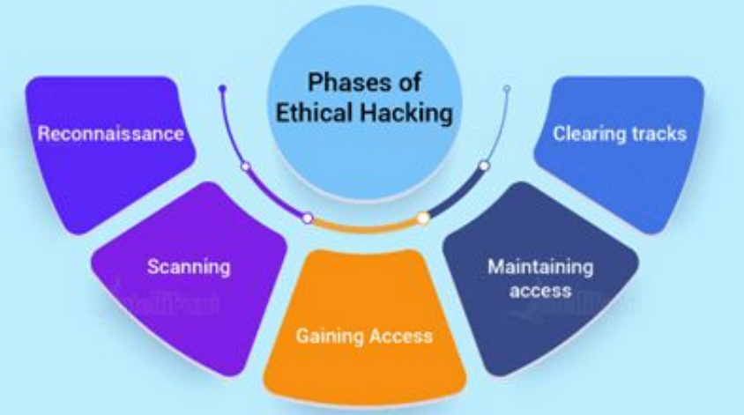

There are multiple phases involved in any elaborate hacking

process.

1. **Reconnaissance:**

* Objective: Gather information about the target system or network.
* Example: A penetration tester may use publicly available information, such as domain names, IP addresses, and organizational details, to build a profile of the target.

1. **Scanning:**

* Objective: Identify live hosts, open ports, and services running on the target.
* Example: Using network scanning tools like Nmap or Nessus to discover active devices, open ports, and potential vulnerabilities on the target network.

1. **Gaining Access (or Gaining a Foothold):**

* Objective: Exploit vulnerabilities to gain initial access to the system.
* Example: Attempting to exploit known vulnerabilities in software or misconfigurations to gain unauthorized access. This could involve using techniques like SQL injection, cross-site scripting (XSS), or exploiting weak passwords.

1. **Maintaining Access:**

* Objective: Establish a persistent presence on the system to simulate a real-world threat.
* Example: Creating backdoors or planting malware to maintain access even if the initial vulnerability is patched. This phase helps assess an organization's ability to detect and respond to ongoing attacks.

1. **Analysis:**

* Objective: Collect and analyze data from the compromised system for further exploitation or to identify additional vulnerabilities.
* Example: Extracting sensitive information, such as user credentials or critical data, to demonstrate the potential impact of a successful cyberattack.

1. **Covering Tracks:**

* Objective: Erase or conceal evidence of the ethical hacking activities to simulate an attacker covering their tracks.
* Example: Deleting logs, modifying timestamps, or taking other measures to make it harder for defenders to trace the ethical hacker's activities.

1. **Reporting:**

* Objective: Document and communicate findings, including vulnerabilities discovered, the extent of potential damage, and recommendations for remediation.
* Example: Providing a detailed report that outlines the security weaknesses identified during the ethical hacking process, along with prioritized recommendations for mitigating those vulnerabilities.

1. **Post-Testing Actions:**

* Objective: Assist the organization in implementing security measures to address identified vulnerabilities.
* Example: Collaborating with the organization's IT and security teams to implement patches, configuration changes, or other measures to enhance the security posture based on the ethical hacker's recommendations.

Throughout these phases, ethical hackers follow a strict code of ethics and adhere to legal guidelines to ensure that their activities are authorized, transparent, and conducted in a responsible manner. The goal is to help organizations improve their security by proactively identifying and addressing vulnerabilities before malicious actors can exploit them.